Architectural Components - Migration

📝 Definition
# Source: AI Source: Provided by: [Data Path: Persons Table -> ID Column: 1, Name_En Column: Motasem Essam] -> From: [ChatGPT] on [1/23/2026]
A Migration is a component or mechanism responsible for managing changes to the database structure and data over time.
It provides a controlled way to:
- Create database tables
- Modify existing tables
- Add or remove columns
- Change relationships
- Update existing data
👉 Think of Migration as a version control system for the database.
Just like source code changes over time, database structure also evolves. Migrations keep those changes organized and repeatable.

🔑 Responsibilities of Migration
# Source: AI Source: Provided by: [Data Path: Persons Table -> ID Column: 1, Name_En Column: Motasem Essam] -> From: [ChatGPT] on [1/23/2026]
1. Create Database Structure
Migrations can create:
- Tables
- Indexes
- Relationships
- Constraints
Example:
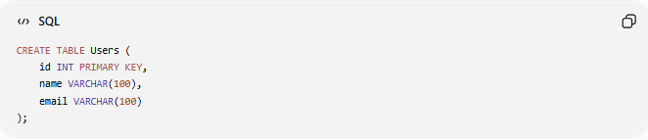
CREATE TABLE Users (
id INT PRIMARY KEY,
name VARCHAR(100),
email VARCHAR(100)
);

2. Modify Existing Database Schema
Example: Adding a new column.
Before:
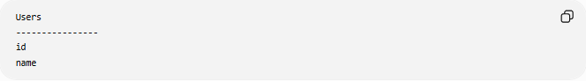
Users
----------------
id
name
Migration:
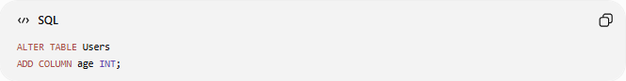
ALTER TABLE Users
ADD COLUMN age INT;
After:
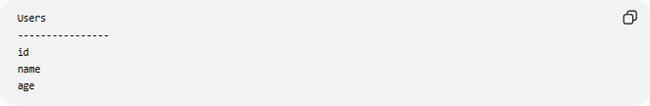
Users
----------------
id
name
age

3. Track Database Versions
Each migration represents a database change.
Example:
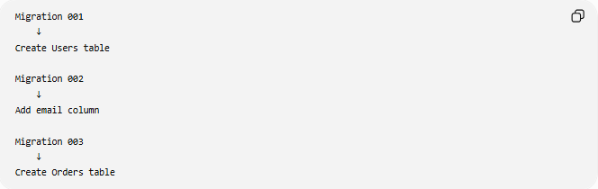
Migration 001
↓
Create Users table

Migration 002
↓
Add email column

Migration 003
↓
Create Orders table
The application knows which changes have already been applied.

4. Maintain Database Consistency
Migration ensures that:
- Developers have the same database structure
- Testing environments match production
- Changes are applied safely

🧱 Example
# Source: AI Source: Provided by: [Data Path: Persons Table -> ID Column: 1, Name_En Column: Motasem Essam] -> From: [ChatGPT] on [1/23/2026]
Migration File
Example:
001_create_users_table.sql
Content:
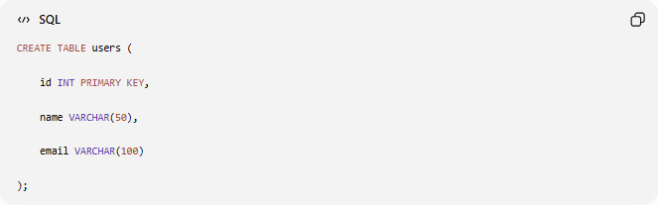
CREATE TABLE users (

id INT PRIMARY KEY,

name VARCHAR(50),

email VARCHAR(100)

);
Another migration:
002_add_phone_column.sql
Content:
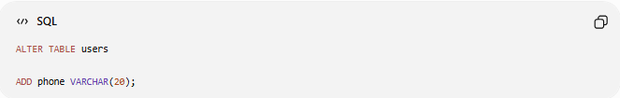
ALTER TABLE users

ADD phone VARCHAR(20);

🔄 Migration Workflow
# Source: AI Source: Provided by: [Data Path: Persons Table -> ID Column: 1, Name_En Column: Motasem Essam] -> From: [ChatGPT] on [1/23/2026]
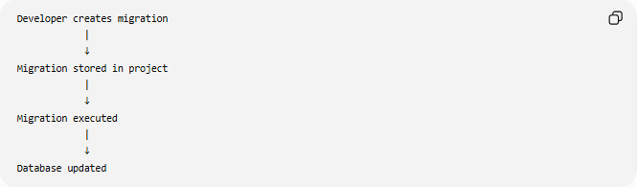
Developer creates migration
|
↓
Migration stored in project
|
↓
Migration executed
|
↓
Database updated

Example Using Code
Migration
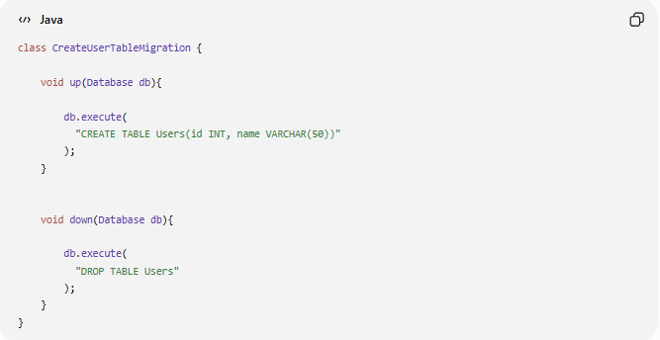
class CreateUserTableMigration {

void up(Database db){

db.execute(
"CREATE TABLE Users(id INT, name VARCHAR(50))"
);
}

void down(Database db){

db.execute(
"DROP TABLE Users"
);
}
}
Here:
up()
- Applies the change
down()
- Reverses the change

⬆️ Up Migration and ⬇️ Down Migration
# Source: AI Source: Provided by: [Data Path: Persons Table -> ID Column: 1, Name_En Column: Motasem Essam] -> From: [ChatGPT] on [1/23/2026]
Up Migration
Applies a change.
Example:
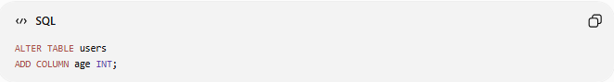
ALTER TABLE users
ADD COLUMN age INT;

Down Migration
Rolls back the change.
Example:
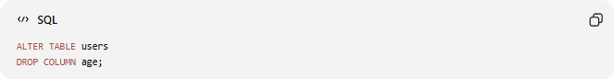
ALTER TABLE users
DROP COLUMN age;

❌ Bad Example (Manual Database Changes)
# Source: AI Source: Provided by: [Data Path: Persons Table -> ID Column: 1, Name_En Column: Motasem Essam] -> From: [ChatGPT] on [1/23/2026]
Developer A:
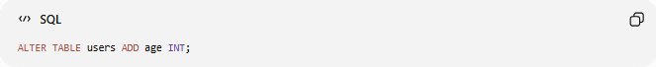
ALTER TABLE users ADD age INT;
Developer B:
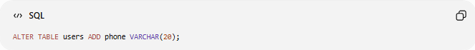
ALTER TABLE users ADD phone VARCHAR(20);
Problems:
- No history
- Hard to reproduce
- Different environments become inconsistent

✅ Good Example (Using Migration)
# Source: AI Source: Provided by: [Data Path: Persons Table -> ID Column: 1, Name_En Column: Motasem Essam] -> From: [ChatGPT] on [1/23/2026]
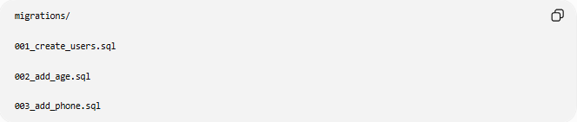
migrations/

001_create_users.sql

002_add_age.sql

003_add_phone.sql
Benefits:
- Database history is clear
- Easy setup for new developers
- Safe deployment process

🔄 Migration in Different Architectures
# Source: AI Source: Provided by: [Data Path: Persons Table -> ID Column: 1, Name_En Column: Motasem Essam] -> From: [ChatGPT] on [1/23/2026]
Clean Architecture
Migration belongs to:
Infrastructure / Data Layer
because it deals with database structure.

MVC / MVVM
Migration is independent from:
- View
- Controller
- ViewModel
It supports the persistence layer.

DevOps / CI-CD
Migrations are executed during deployment:
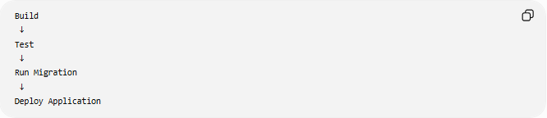
Build
↓
Test
↓
Run Migration
↓
Deploy Application

⚠️ Common Migration Mistakes

❌ Editing old migrations
# Source: AI Source: Provided by: [Data Path: Persons Table -> ID Column: 1, Name_En Column: Motasem Essam] -> From: [ChatGPT] on [1/23/2026]
Example:
Changing:
001_create_users.sql
after it was already deployed.
Problem:
- Different environments may have different histories.

❌ Putting business logic inside migrations
# Source: AI Source: Provided by: [Data Path: Persons Table -> ID Column: 1, Name_En Column: Motasem Essam] -> From: [ChatGPT] on [1/23/2026]
Bad:
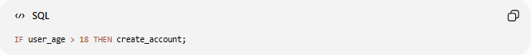
IF user_age > 18 THEN create_account;
Business rules belong to:
- Model
- Service

❌ Deleting migrations
# Source: AI Source: Provided by: [Data Path: Persons Table -> ID Column: 1, Name_En Column: Motasem Essam] -> From: [ChatGPT] on [1/23/2026]
Migrations are historical records.

Migration vs Repository
# Source: AI Source: Provided by: [Data Path: Persons Table -> ID Column: 1, Name_En Column: Motasem Essam] -> From: [ChatGPT] on [1/23/2026]
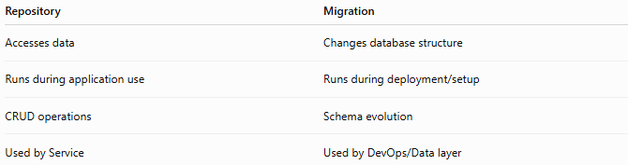
Repository | Migration
Accesses data | Changes database structure
Runs during application use | Runs during deployment/setup
CRUD operations | Schema evolution
Used by Service | Used by DevOps/Data layer

Migration vs Model
# Source: AI Source: Provided by: [Data Path: Persons Table -> ID Column: 1, Name_En Column: Motasem Essam] -> From: [ChatGPT] on [1/23/2026]
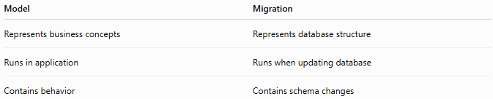
Model | Migration
Represents business concepts | Represents database structure
Runs in application | Runs when updating database
Contains behavior | Contains schema changes

💡 Key Idea
# Source: AI Source: Provided by: [Data Path: Persons Table -> ID Column: 1, Name_En Column: Motasem Essam] -> From: [ChatGPT] on [1/23/2026]
Migration manages how the database evolves; Repository manages how the application accesses the database.

🧾 Summary
# Source: AI Source: Provided by: [Data Path: Persons Table -> ID Column: 1, Name_En Column: Motasem Essam] -> From: [ChatGPT] on [1/23/2026]
Migration:
✅ Tracks database changes
✅ Creates and modifies schema
✅ Keeps environments synchronized
✅ Provides version history
✅ Supports safe deployments
The main responsibility of Migration is:
"Move the database from one version to another in a controlled and repeatable way."

